UNITED  NATIONS | 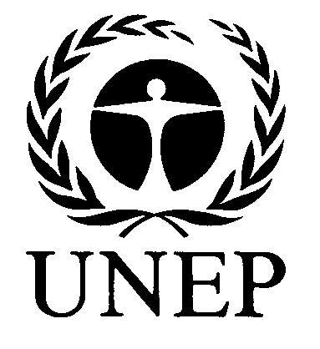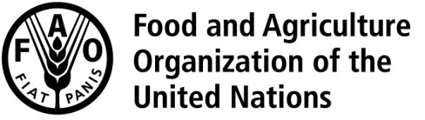 |  | RC
 |  | UNEP/FAO/RC/COP.8/INF/11∗
 | Rotterdam Convention on the Prior Informed Consent Procedure for Certain Hazardous Chemicals and Pesticides in International Trade | Distr.: General  17 February 2017  English only
Conference of the Parties to the
Rotterdam Convention on the Prior
Informed Consent Procedure for Certain
Hazardous Chemicals and Pesticides in
International Trade
Eighth meeting
Geneva, 24 April–5 May 2017
Item 5 (b) (i) of the provisional agenda∗∗
Matters related to the implementation of the Convention:
listing of chemicals in Annex III to the Convention:
consideration of chemicals for inclusion in Annex III
Compilation of comments received from Parties relating to the recommendation by the Chemical Review Committee to listing of chemicals and severely hazardous pesticide formulations in Annex III to the Rotterdam Convention
Note by the Secretariat
As referred to in the note by the Secretariat on Chemical Review Committee: developments for action by the Conference of the Parties (UNEP/FAO/RC/COP.8/7), the annex to the present note sets out a compilation of comments received from Parties relating to the listing of chemicals and severely hazardous pesticide formulations in Annex III to the Rotterdam Convention recommended by the Chemical Review Committee. The comments were submitted by the European Union, Jordan, Paraguay, Saudi Arabia, Serbia, Syrian Arab Republic and Vietnam. The present note, including its annex, has not been formally edited.

Annex
European Union
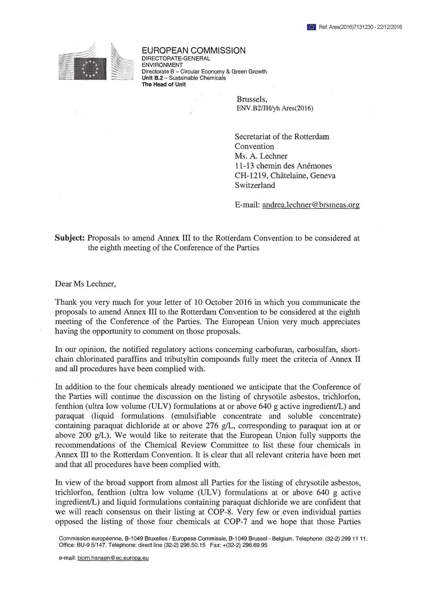

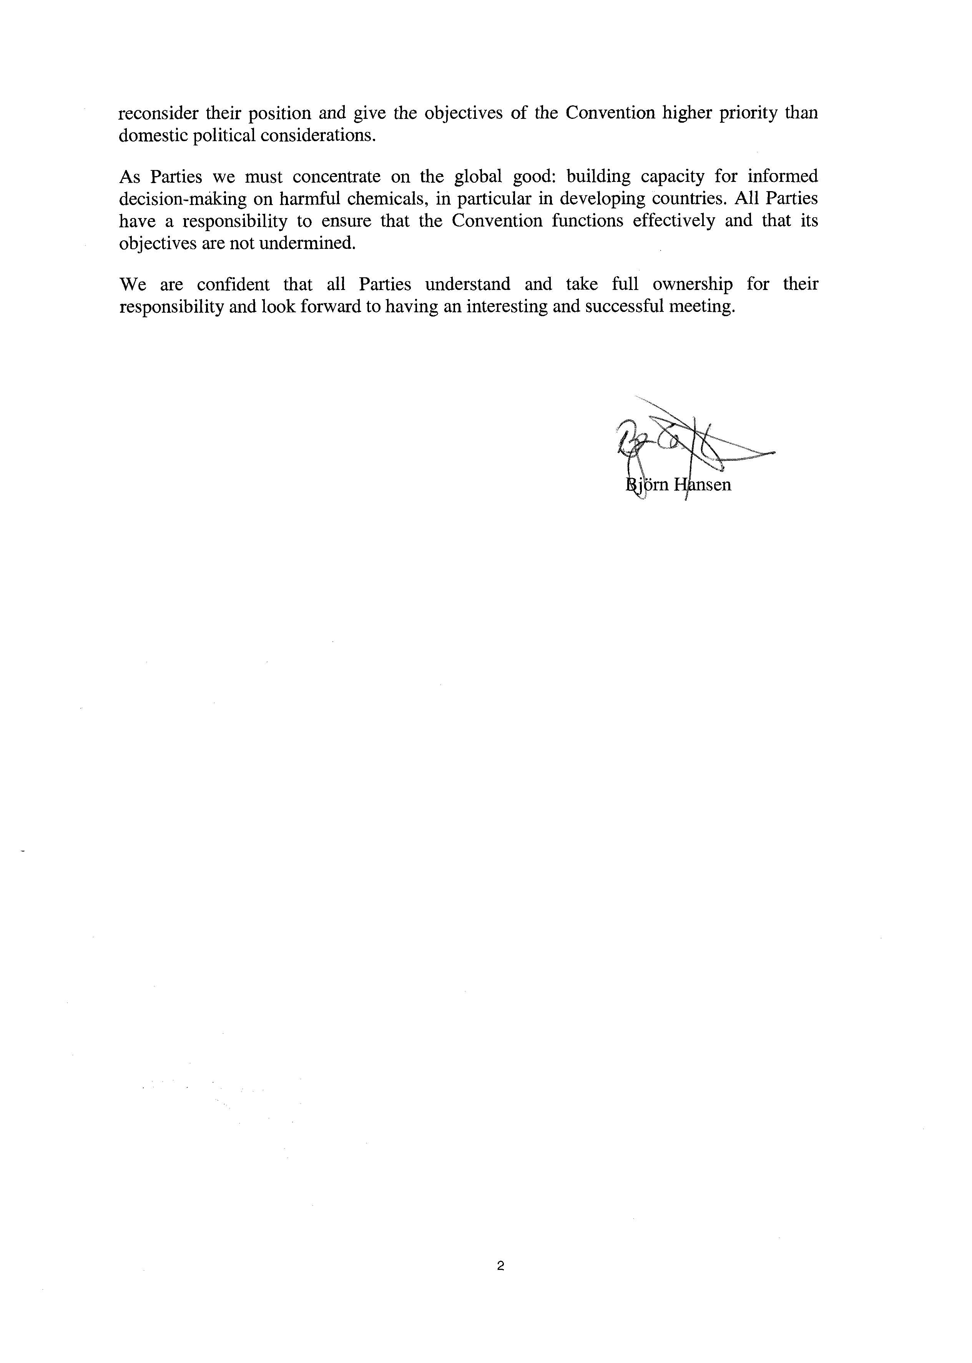

Jordan
بعد التحية

اشارة الى المراسلة الواردة من قبل اتفاقية روتردام بخصوص اقتراح تعديل المرفق الثالث من اتفاقية روتردام للنظر فيه بالاجتماع الثامن عشر لمؤتمر الاطراف

حيث سيتم ادراج المواد الفعالة (Carbosulfan , Carbofuran ) في المرفق الثالث .

ارجو التكرم بالعلم بان :
1- المادة الفعالة Carbofuran قد تم منع التداول بها في الاردن للسوق المحلي وقد تم منع تصنيعها لاغراض التصدير ايضاً بتاريخ 14/1/2002
2- المادة الفعالة Carbosulfan قد تم منع التداول بها في الاردن للسوق المحلي وقد تم منع تصنيعها لاغراض التصدير ايضاً بجلسة لجنة تسجيل المبيدات رقم 780 تاريخ 24/7/2016

واقبلوا الاحترام
م. خلود عرنكي
مدير مديرية الوقاية وصحة النبات
(مرفق الكتاب الرسمي الصادر بخصوص تسمية ضابط الارتباط مع الاتفاقية )

Eng. Kholoud Aranki
Director of Plant Protection& Phytosanitary Directorate
IPPC Jordanien Contact Point
Rotterdam Convention Focal Point
P.O.Box:961044 Amman11196 Jordan
Mobile : 00962795444392
Office : 00962-6-5686151 ext 458
Fax:00962-6-5625714

(English translation)

Reference is made to the correspondence received from the Rotterdam Convention regarding the proposal to amend Annex III to the Rotterdam Convention for consideration by the eighteenth meeting of the Conference of the parties which will include active substances (Carbosulfan, Carbofuran) in Annex III.
Please kindly note that:
- The active substance Carbofuran has been banned for domestic market and also for manufacture for export purposes as of 14/1/2002.
- The active substance Carbosulfan has been banned in Jordan for domestic market and also for manufacture for export purposes by the Pesticide Registration Commission number 780 as of 24/7/2016.
Best regards,
Eng. Kholoud Aranki
Director of Plant Protection& Phytosanitary Directorate

السادة سكرتاريا اتفاقية روتردام

تحية طيبة وبعد ،،،

(DNA )كما تعلمون فإن وزارة الصحة هي السلطة الوطنية المعينة

للرقابة على المواد الكيماوية الصناعية ، وقد قامت بتاريخ 14/11/2012 بتحديث قوائم المواد الكيمائية الممنوعة والمشروطة وعليه فقد تم إضافة مركبات القصدير لتلك ضمن التحديد الوارد في المرفق رقم (1)، وبالتالي فإنها مشروطة لدينا في الأردن ضمن فئة المواد الكيميائية الصناعية .

اما بالنسبة للتغيير التحريري المنوي إجرائه لتسمية المادة الكيميائية " البارافينات المكلورة قصيرة السلسلة (short-chained chlorinated paraffins) "

الى البارفينات المكلورة القصيرة السلسلة (short-chain chlorinated paraffins) "

؛ فأرجو العلم أن التسمية المطلوبة لهذا المركب هي المعتمدة ضمن قوائم وزارة الصحة المشروطة " Short chain chlorinated paraffins."

( حسب المرفق رقم (2)

وبناءً عليه الإجراءات النافذة لدى وزارة الصحة هي ذات الإجراءات المقترحة من جانبكم .

وتفضلوا بقبول فائق الاحترام

مدير مديرية صحة البيئة / وزارة الصحة الأردنية

م. صلاح الحياري

(English translation)

As you know that the Ministry of Health is the Designated National Authority (DNA) for the control of industrial chemicals
With regard to control of industrial chemicals, we have updated the list of prohibited and restricted chemicals on 14 Nov. 2012. Tin compounds were one of the chemicals added to the restricted chemicals list as part of the industrial chemical compounds category as set out in the attached Annex I.
With regard to the editorial change in naming of the chemical SCCP from (short-chained chlorinated paraffins) to (short-chain chlorinated paraffins”), I would like to note that the name given for this chemical in the updated list of restricted chemicals of the Ministry of Health mentioned above is “Short chain chlorinated paraffins.” as set out in the attached Annex II
Accordingly, the Ministry of Health supports the proposed action.
Yours faithfully,
Environmental Health Directorate

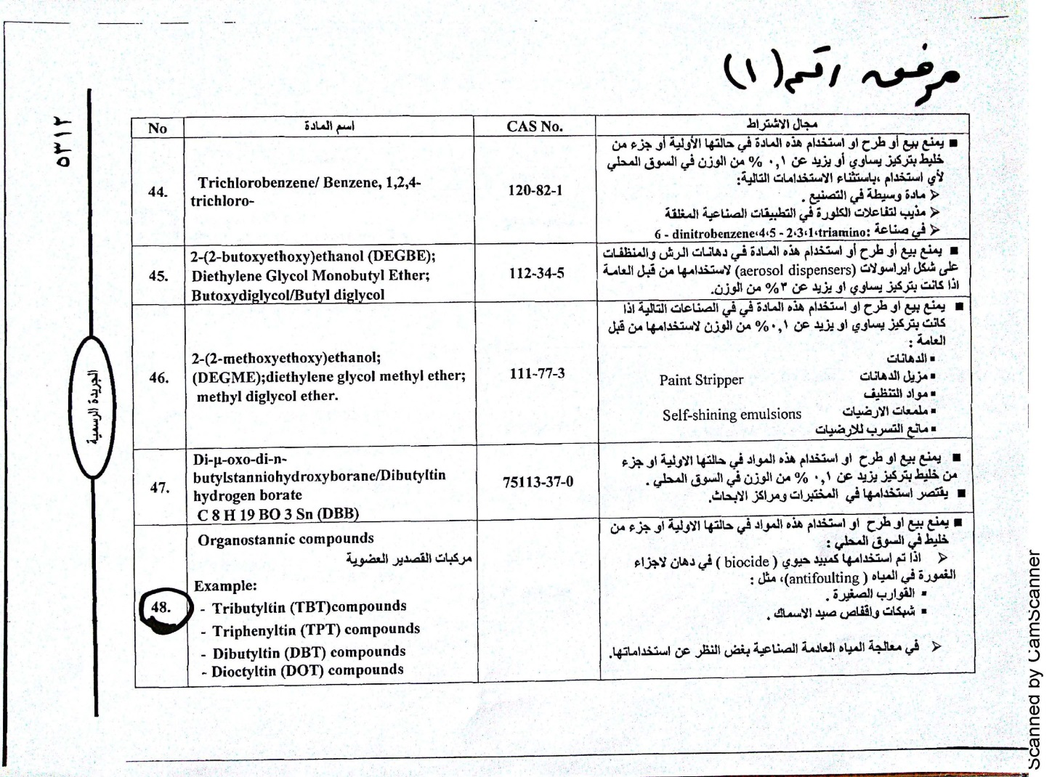
(Annex I)

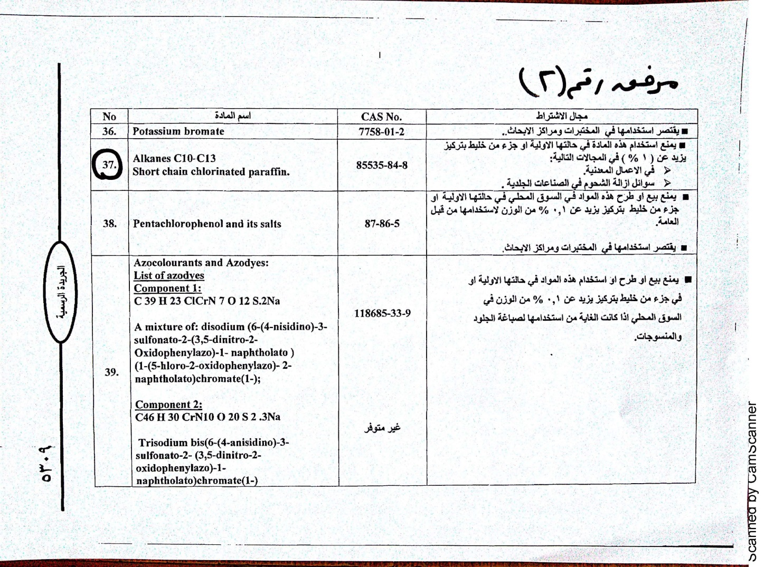
(Annex II)
Paraguay
En referencia a la Comunicacion recibida de la Secretaria del Convenio de Rotterdam con relacion a la presentacion de las Partes de Comentarios sobre el texto de enmiendas propuestas al Anexo III del Convenio de Rotterdam y en base a las recomendaciones del Comite de Examen de Productos Quimicos sobre la inclusion de productos quimicos en el anexo III, las cuales seran consideradas en la Octava Reunión de la Conferencia de las Partes a llevarse a cabo del 24 abril al 05 de mayo del 2017.

Al respecto, despues de haber analizado dichos documentos por la Direccion de Agroquímicos de ésta institucion, se informa que no hay objeciones a los mismos.

Ing. Agr. Fatima Alfonso.
Dpto. Relaciones Internacionales
SENAVE

(English translation)

With reference to the communication received from the Secretariat of the Rotterdam Convention concerning the submission of Parties’ comments on the text of the proposed amendments to Annex III to the Rotterdam Convention and on the basis of the recommendations of the Chemical Review Committee, which will be considered at the eighth meeting of the Conference of the Parties to be held from 24 April to 5 May 2017.

In this regard, after reviewing these documents by the Directorate of Agrochemicals of this institution, it is reported that there are no objections to them.

Saudi Arabia
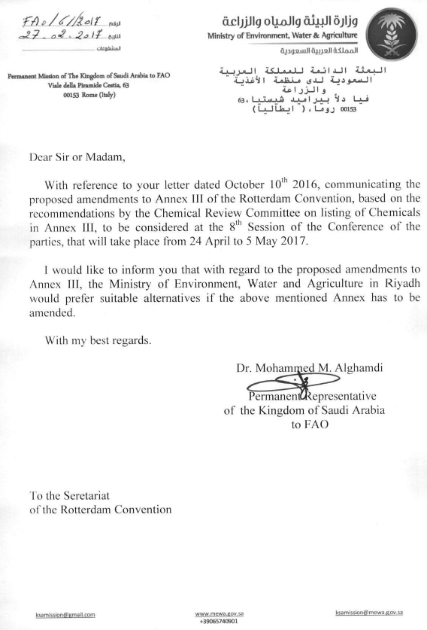

Serbia
I would like to inform you that Republic of Serbia supports recommendation on the listing of industrial chemicals and pesticides mentioned in the letter with proposals in Annex III to the Convention.

Kind regards,

Suzana Andrejevic Stefanovic

Head of Division for Chemicals Management
Division for Chemicals Management
Department for Planning and Management in the Environment
Omladinskih brigada 1 - 11070 Novi Beograd
Telefon: 011/7155-221
eMail: Suzana.A.Stefanovic@eko.minpolj.gov.rs
Web: www.eko.minpolj.gov.rs.

Syrian Arab Republic
Dear Sir

The pesticide: Carbosulfan Gas No : 55285-14-8 (insecticide) is forbidden to use in the Syrian Arab Republic in all its forms by the Minister of Agriculture No. 1960 / T Date 9/3/2010.

The pesticide: Carbofuran Gas No: 1563-66-2 (insecticide and Nimatoda) It is forbidden to use in the Syrian Arab Republic in all its forms by the Minister of Agriculture No. 10 / T Date 10/4/1990 and No. 1969 / w Date 12/5/1999.

Best regards

Shagaf Nahawi
DNA CP Rotterdam convention
chemical safety Directorate
Ministry of State for Environment Affairs
Damascus-Syrian Arab Republic
Tel: +963 955 28 4393
Email: shagafalnahawi@yahoo.com

Vietnam
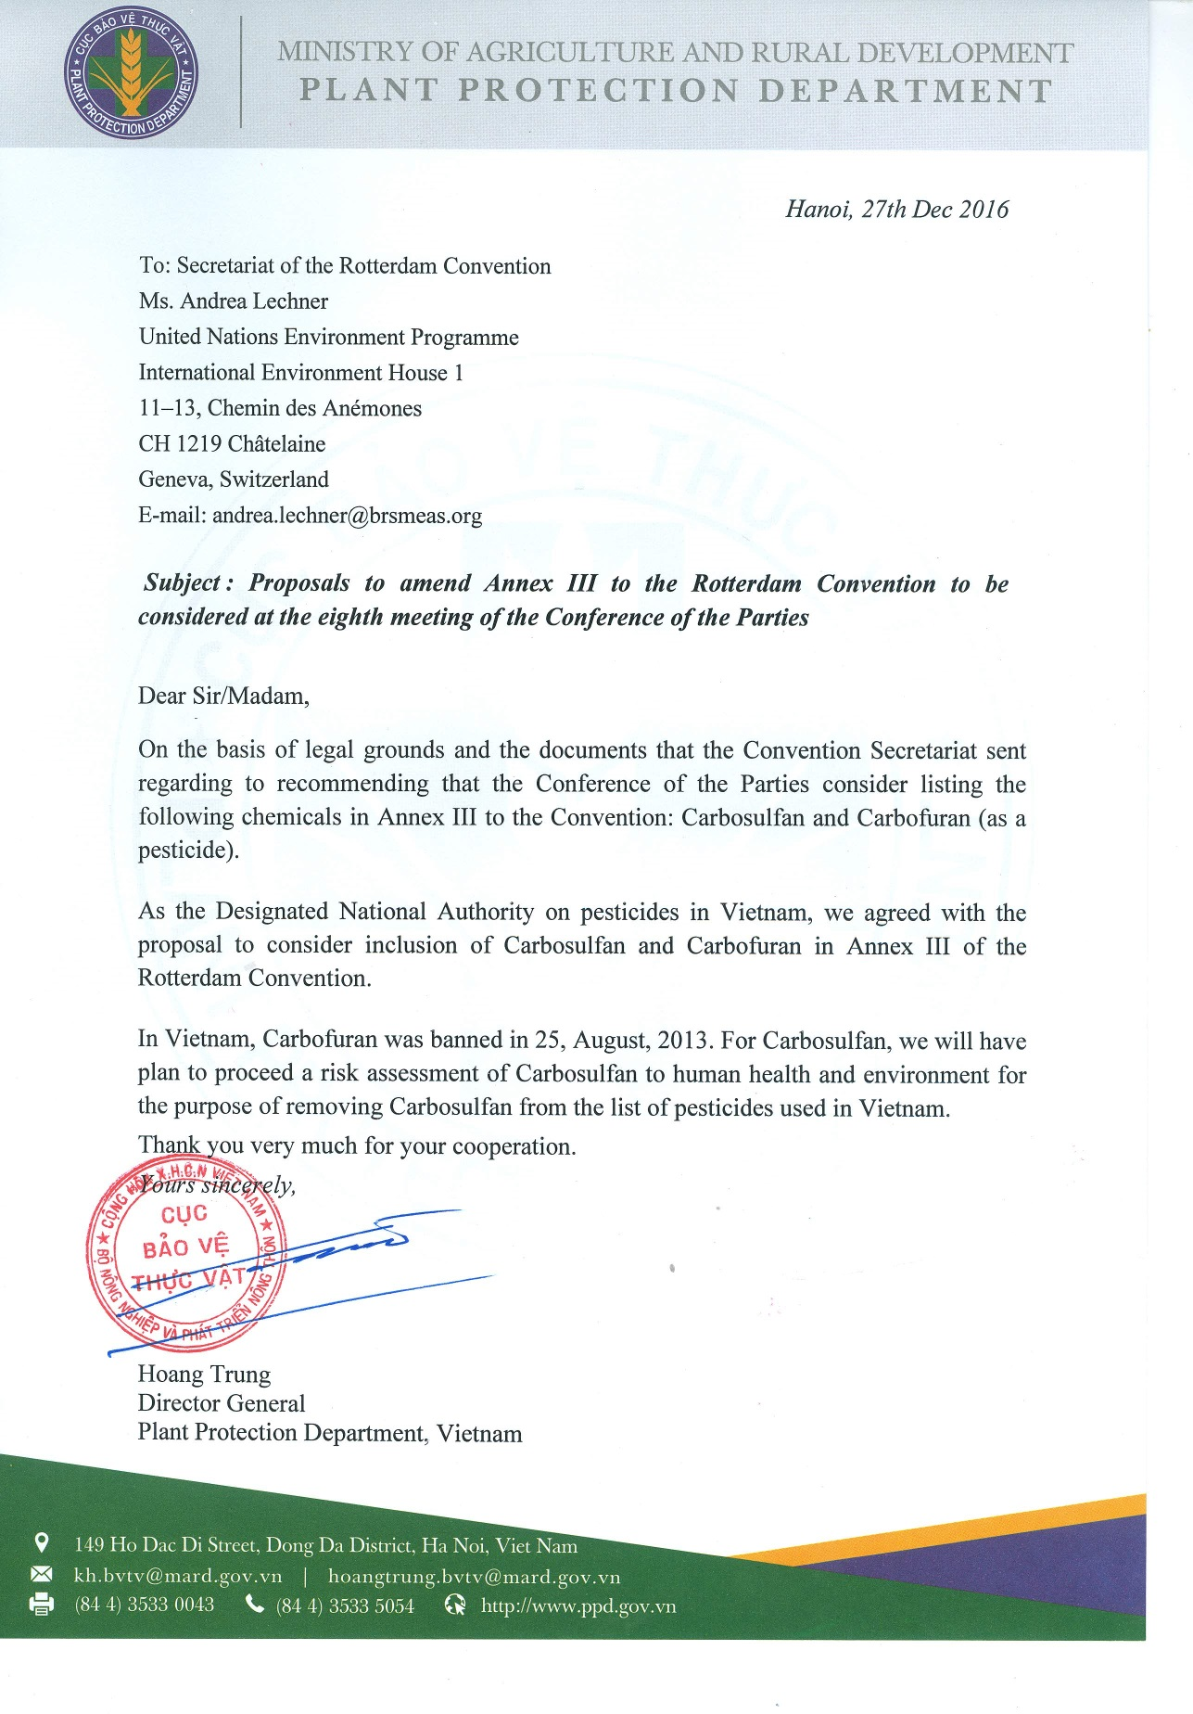
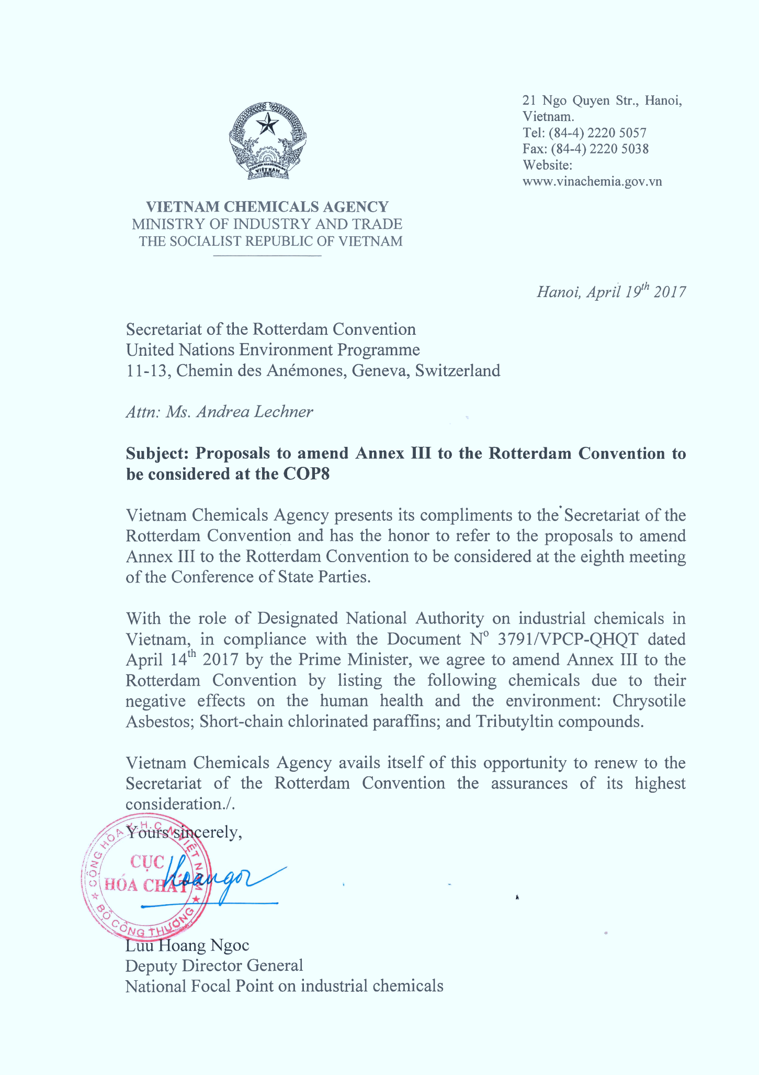

∗ Second reissue for technical reasons (21 April 2017).
∗∗ UNEP/FAO/RC/COP.8/1.

