UNITED  NATIONS |  |  | PIC
 |  | UNEP/FAO/PIC/ICRC.5/INF/2
 | United Nations  Environment Programme  Food and Agriculture Organization  of the United Nations | Distr.: General  19 January 2004  English only

Interim Chemical Review Committee

Fifth session
Geneva, 2–6 February 2004
Item 2 (b) of the provisional agenda∗

Organizational matters: Organization of work

New experts on the Interim Chemical Review Committee

Note by the secretariat

- The Intergovernmental Negotiating Committee, by decision INC-9/2 adopted at its ninth session, confirmed the nomination of the 29 experts designated for the Interim Chemical Review Committee (document UNEP/FAO/INC.9/21, annex II).

- In a letter of 17 October 2003, Mr. Siaosi Matalavea, nominated by the Government of Samoa, informed the interim secretariat that he was no longer able to serve as a member of the Interim Chemical Review Committee. In a letter of 24 October 2003, the Government of Samoa informed the interim secretariat that Mr. Pimalolo Maiava had been designated as the new expert. Accordingly, Mr. Pimalolo Maiava will serve on the Interim Chemical Review Committee, pending formal confirmation by the Intergovernmental Negotiating Committee at its eleventh session.

- The letters mentioned above and the relevant qualifications of the expert from Samoa are annexed to the present note.

Annex

Nomination and qualifications, as received by the Secretariat

South West Pacific – Samoa: Mr. Pimalolo Maiava

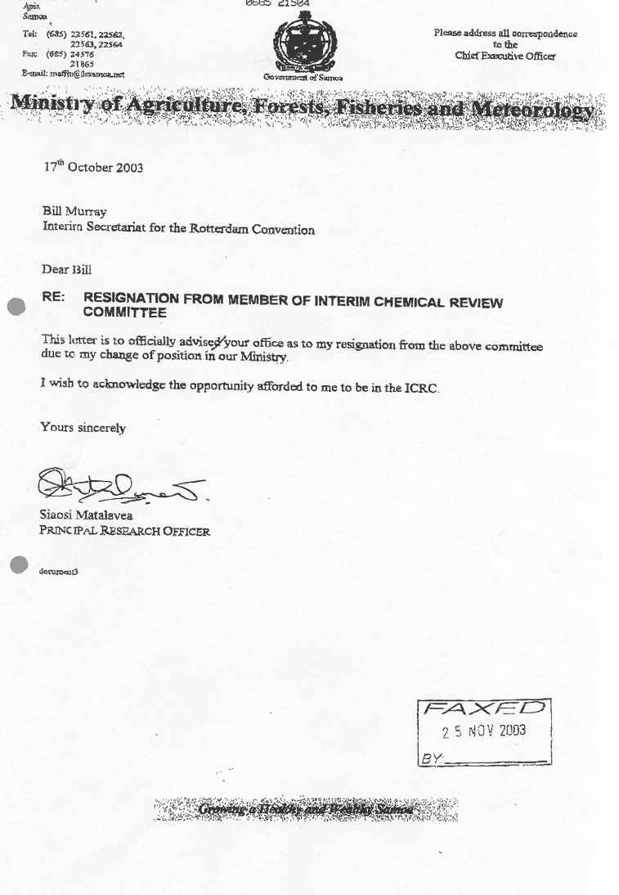

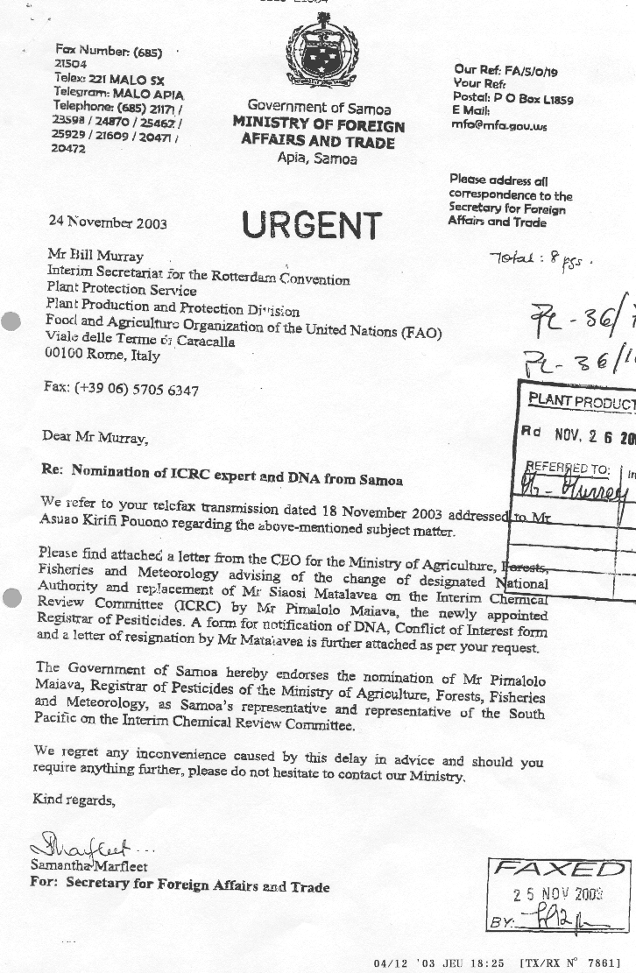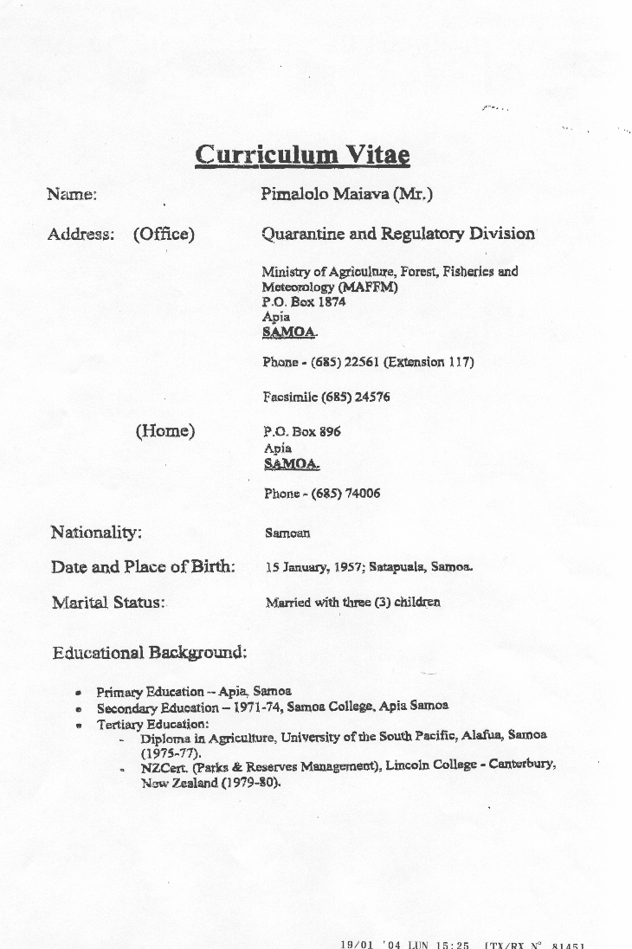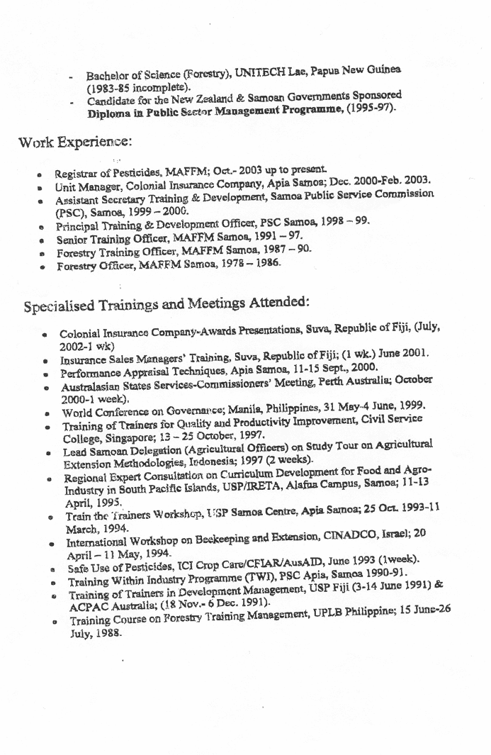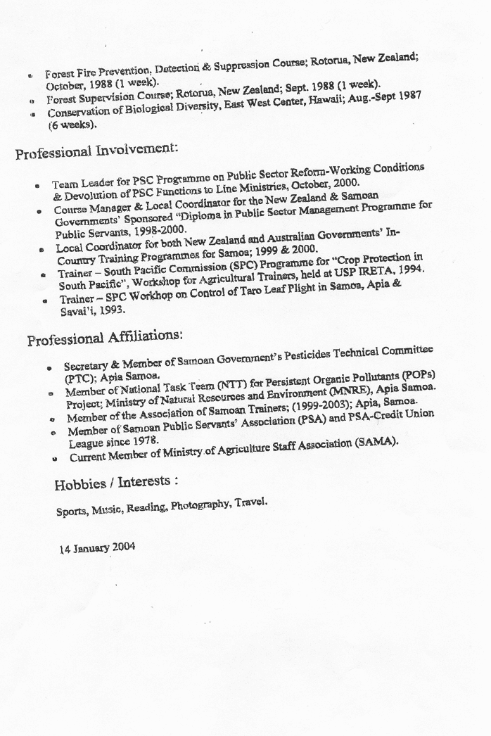

* UNEP/FAO/PIC/ICRC.5/1.

